|  |  |
| --- | --- |
| **Project: New Haven Urgent Care Team# 18** | |
|  | **Test Date: 12/11/2018** |
| **Test Case ID#:** 09 | **Name(s) of Tester(s):** Yiping Ren |
| **Test Description (What are you testing? – you must be specific):**  Do assessments have the nurse’s information associated with it? Can we retreive the nurses  information? |  |
| . |  |

**NOTE: The following information must be provided to be given credit for any test.**

**Test Data (Provide the file name of the script used to insert data, provide a screen capture to reflect data, or provide script here):**

Filename: test9.sql

|  |
| --- |
| SET SQL_SAFE_UPDATES = 0; |
|  | set foreign_key_checks=0; |
|  | DELETE FROM Nurse; |
|  | DELETE FROM Initial_Assessment; |
|  | INSERT INTO Nurse (Employee_ID) VALUES (1); |
|  | INSERT INTO Nurse (Employee_ID) VALUES (2); |
|  | INSERT INTO Initial_Assessment(Assessment_ID, Height, Weight, Temperature, Nurse_ID, Blood_pressure) |
|  | VALUES (1, 5.4, 113, 66, 1, 112); |
|  | INSERT INTO Initial_Assessment(Assessment_ID, Height, Weight, Temperature, Nurse_ID, Blood_pressure) |
|  | VALUES (2, 5.5, 130, 67, 2, 120); |

Reflect data

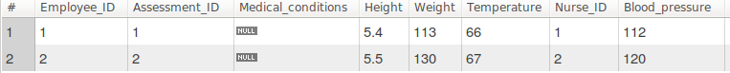

**SQL Query(s) used for testing:**

|  |
| --- |
| SELECT * |
|  | FROM Nurse JOIN Initial_Assessment ON Nurse.Employee_ID = Initial_Assessment.Nurse_ID; |
|  | SET foreign_key_checks=1; |
|  | SET SQL_SAFE_UPDATES = 1; |